ST. PETER’S COLLEGE KOLENCHERY

ENERGY CONSERVATION CELL
ANNUAL REPORT 2021-22

COORDINATORS

DR.SINDHU ISSAC & JOHN C

Energy conservation is the decision and practice of using less energy. Turning off the light when you leave the room, unplugging appliances when they’re not in use and walking instead of driving are all examples of energy conservation. The two main reasons people conserve energy are to gain more control over their energy bill and reduce the demand on the earth’s natural resources. It is the moral responsibility of all citizens to use energy judiciously in everyday life, ensure zero wastage and spread the awareness on the importance of energy conservation for a healthy environment and sustainable future.
Energy Conservation Cell of our college aims to create an awareness about the wise and judicious use of our energy and reducing the wastage of energy for a better future. The activities carried out by this cell during the academic year 2021-22 are:
- World Environment Day Celebrations:
As part of World Environment day celebrations, the Energy Conservation Cell has conducted a competition “Best Energy Saver Award”. The aim of this competition is to create an awareness among the students regarding the wise use of electricity in their houses and to reduce the electricity bill considerably. The best energy saver is declared based on the reduction in the electricity bill ( bill after two months from the submitted electricity bill). The best energy saver award was declared by The Hon’ble VC during the inauguration of the cell activities for the current academic year. The Best energy saver award was bagged by Kum. Manjitha P Raju of II DC Chemistry.

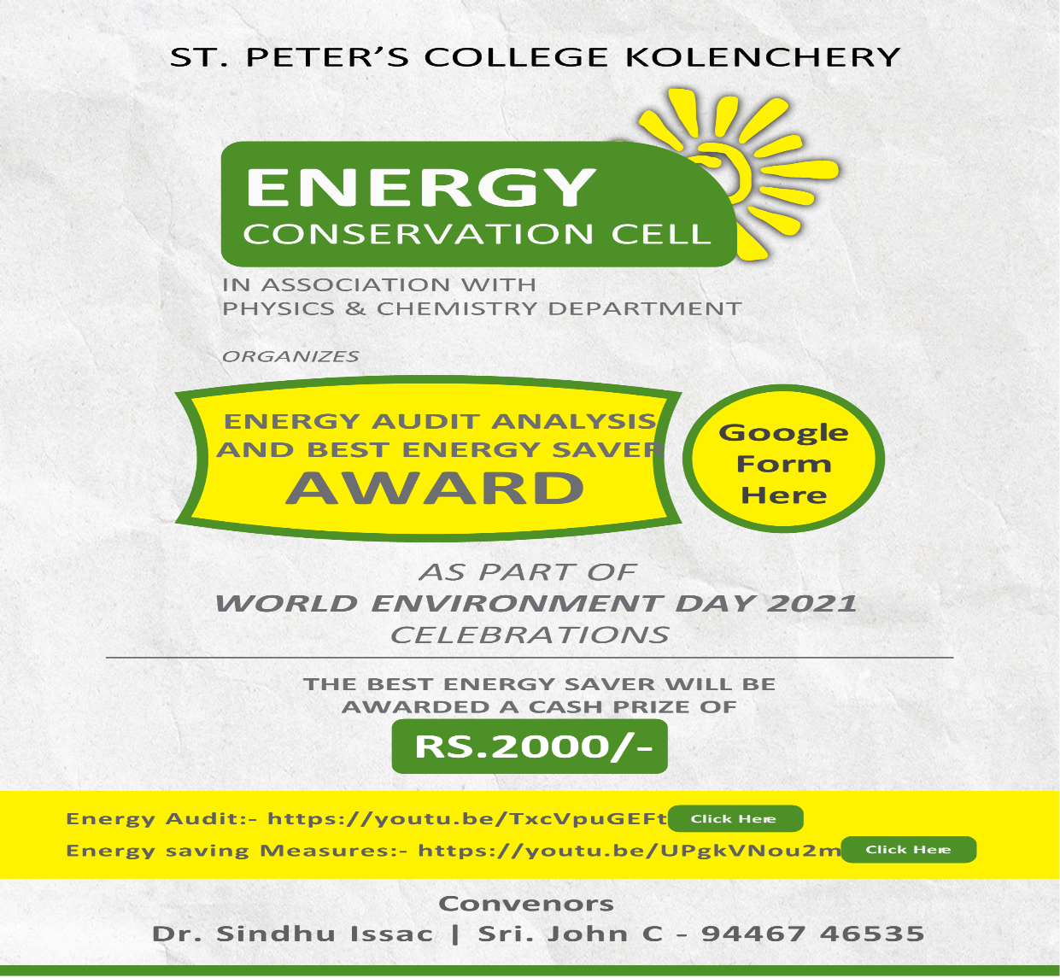

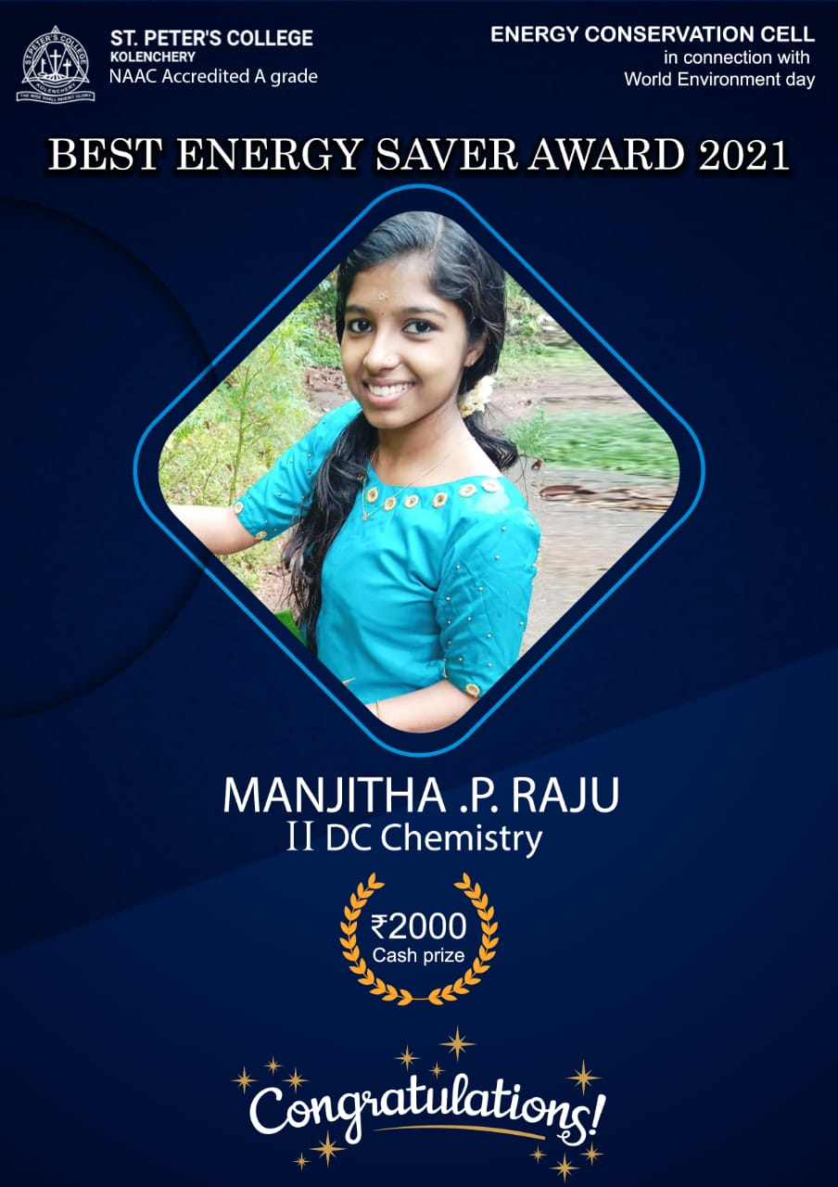

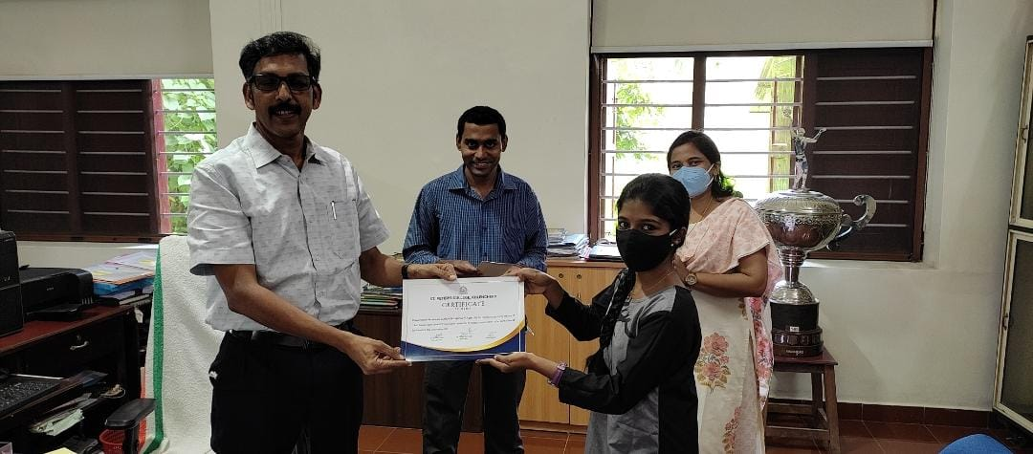
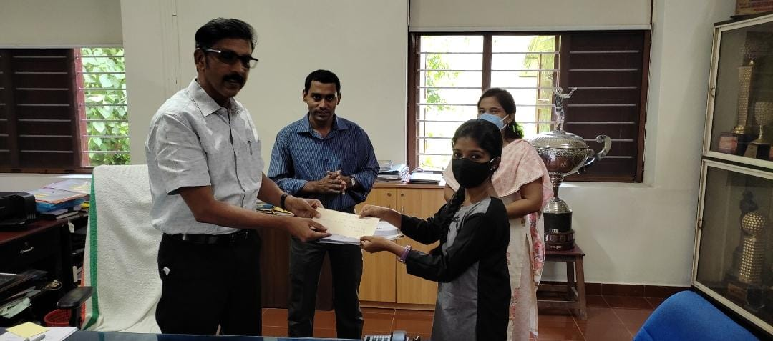

- Energy Conservation Cell Inauguration:

The activities of the club for the academic year 2021-22 was inaugurated by the Hon’ble Vice Chancellor of Mahatma Gandhi university, Prof. Sabu Thomas Sir on 10-09-2021 at 5 pm through online platform Google Meet.
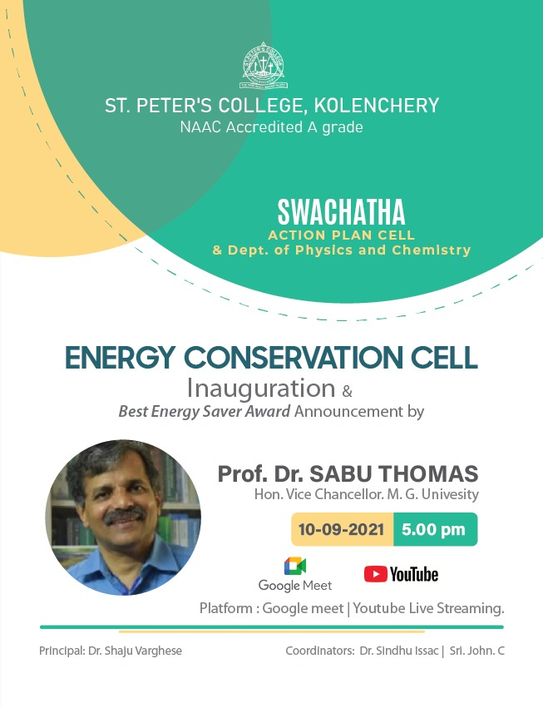
- Energy Conservation Day Celebration:

As part of the energy conservation Day celebrations, the Energy Conservation Cell organized a cycle rally named “ Cyclothon-2021” on December 14, 2021. Principal Dr. Shaju Varghese flagged off the rally. Around 50 students participated in the rally and they have conveyed the message to the public on the importance of conserving energy for a better and sustainable future.

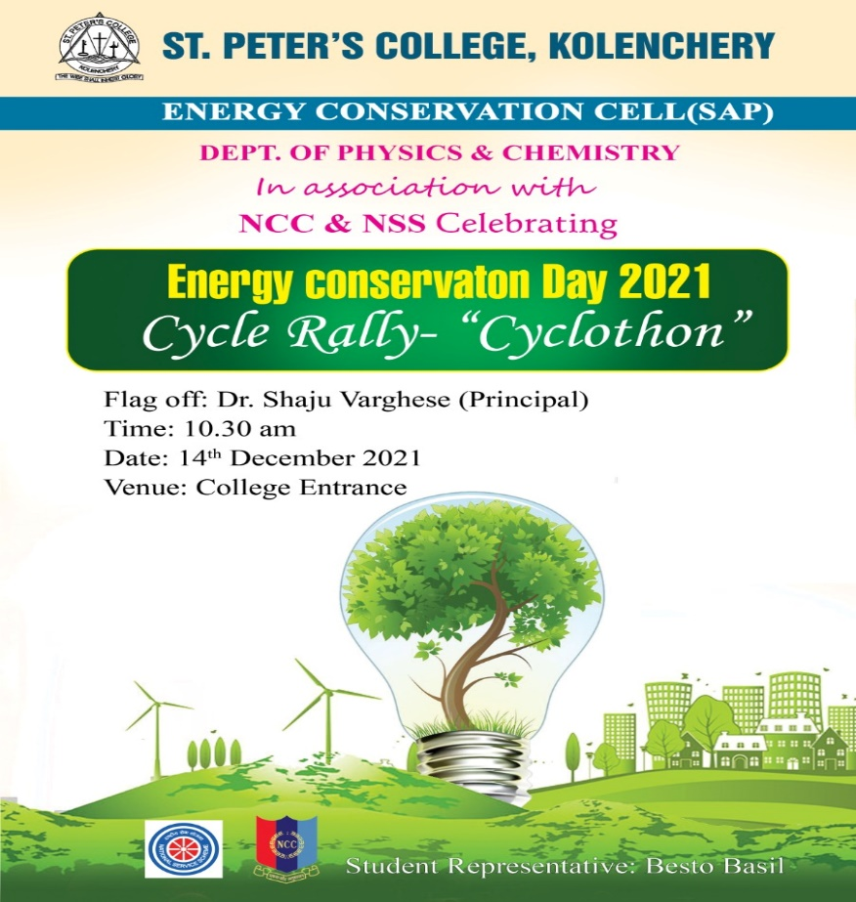

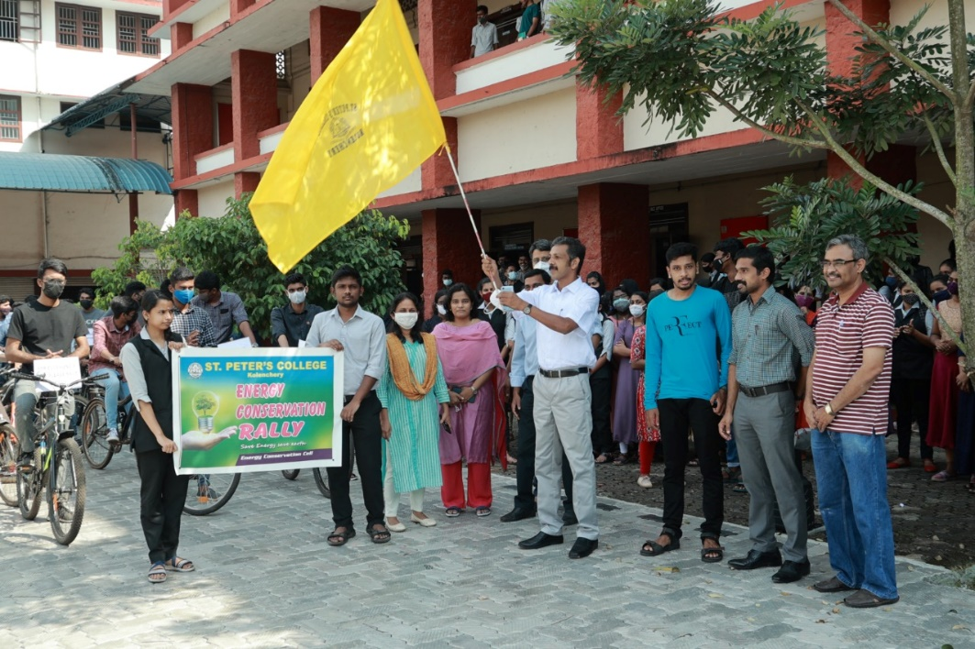
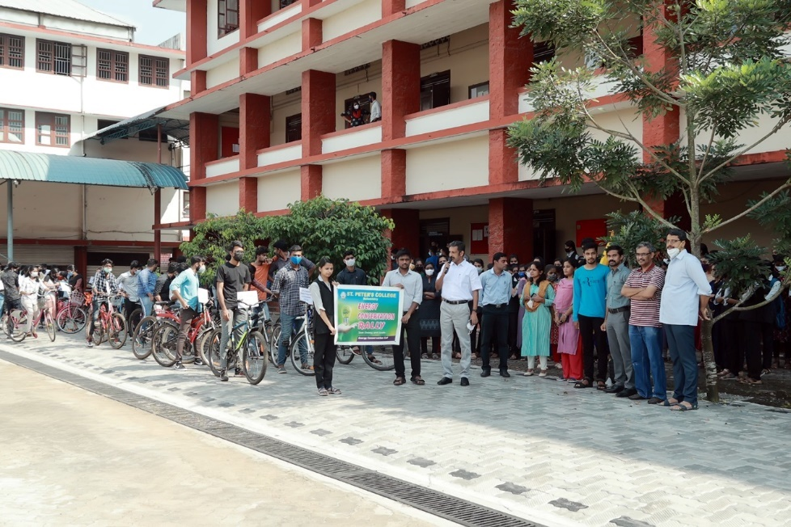

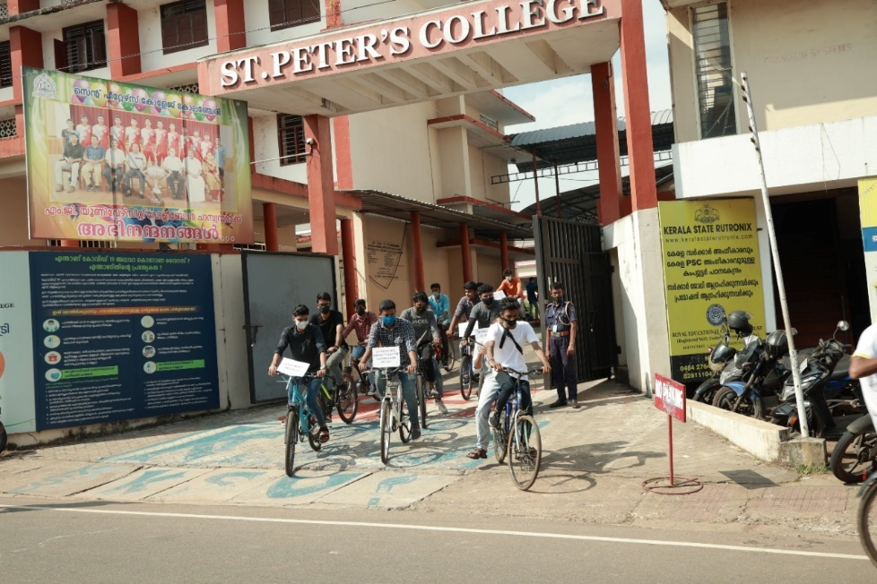

- Webinar on Renewable Energy resources:
Energy Conservation Cell in association with Department of Physics & Chemistry organized a webinar on Renewable Energy Sources by Mr. Manu M Venu, District Engineer, ANERT Ernakulam on 30-11-2021 at 7 pm through Google Meet.
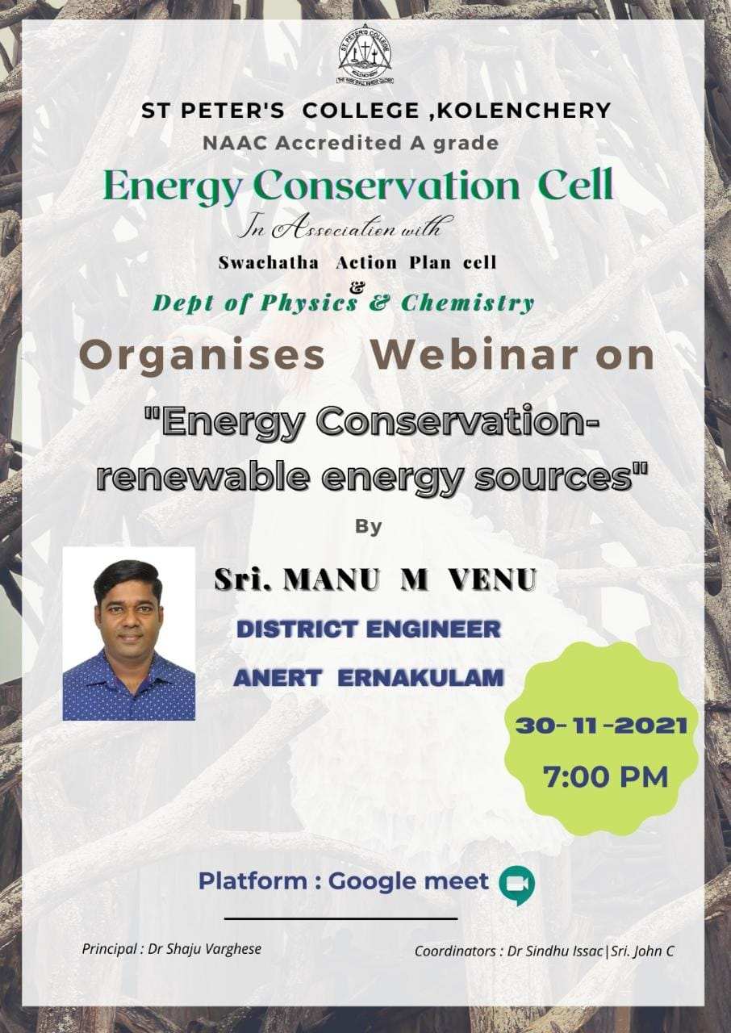
- Sourathejas Program – Registration Counter Inauguration:
Energy Conservation Cell, St. Peter’s College Kolenchery was selected as the campaign partner of ANERT, a Kerala Government organization for the Program on introducing “On Grid Solar Panels” in every house at subsidized rates. The aim of Energy Conservation Cell is to promote the maximum use of Solar energy in every houses so that the electricity consumption can be reduced to a great extent.
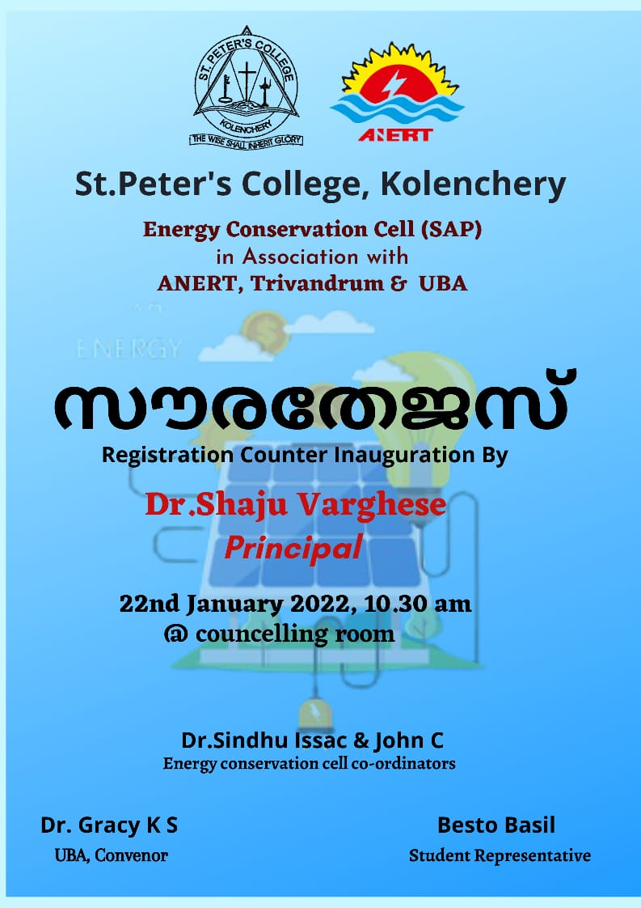
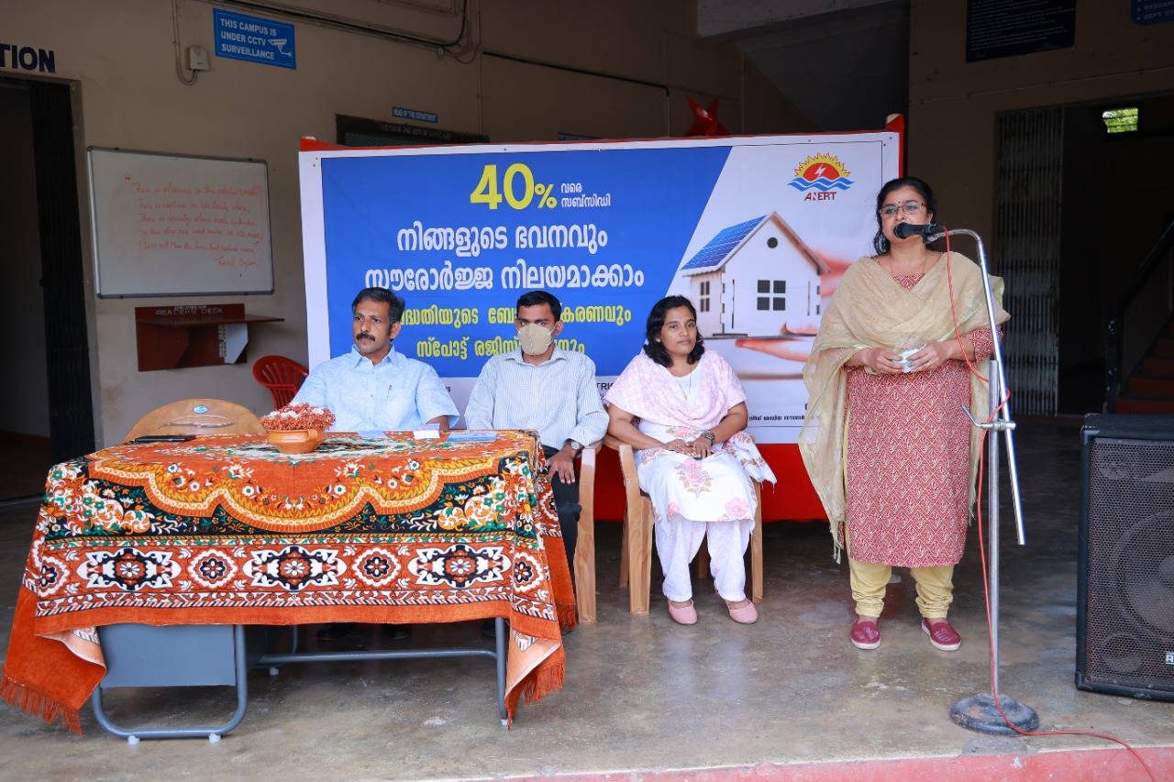
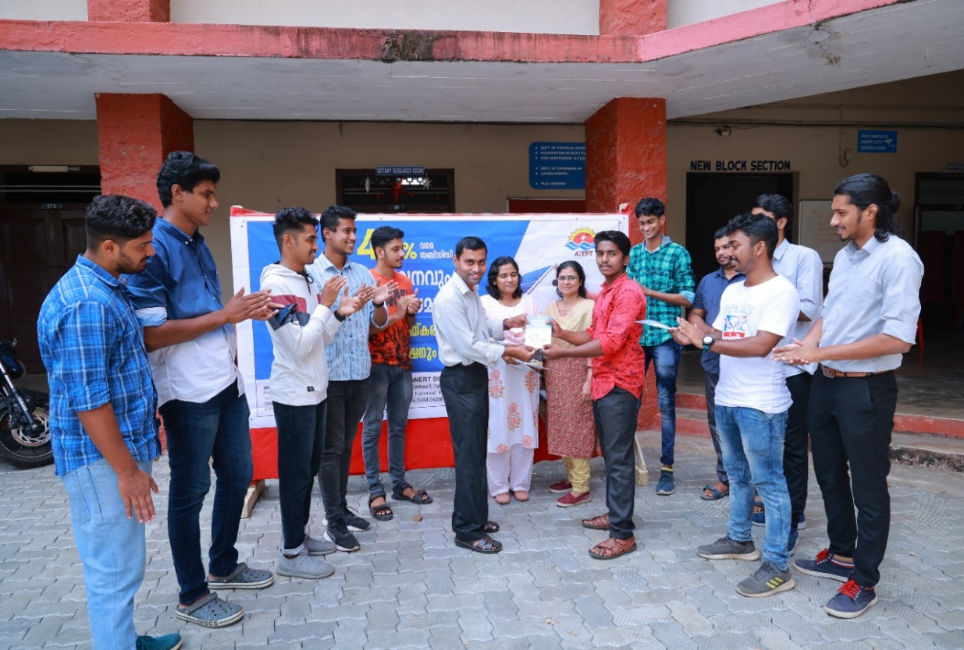
- Sourathejas registration counter at Poothrikka Panchayath:
Energy conservation cell in association with UBA and SAP has arranged a spot registration counter at Poothrikka Panchayath on 09-03-2022 at 2 pm. Mr. Manu M Venu, District Engineer, ANERT Ernakulam has taken a class on this occasion to the to the public.

